Switching between touch and classic view in AEM.

When we access the cq instance and want to enable to classic or touch view by default, we have to change the root mapping setting via config manager.

**Step1:**

Go to configuration manager <http://localhost:4504/system/console/configMgr>

**Step2:**

Search for “Root Mapping”, and you will find the “Day CQ Root Mapping” configuration.



**Step3:**

Change the target path value

For classic: /welcome

For touch: /aem/start.html

Or we can even set the different value where we want the author to land on by default.

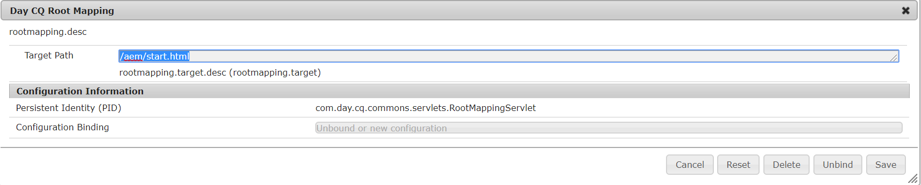

After changing the configuration values, just access <http://localhost:4504/>, it will take you to the respective configured pages.